Liver Disease Screening Using Supervised Machine Learning with Clinically Interpretable Biochemical Indicators
Project proposal report in partial fulfillment of the requirement for the award of the degree of
Bachelor of Technology
in
Computer Science and Engineering (Artificial Intelligence)

Submitted by
Aditya Bhowmik Enrollment No. 1202400035155
Kaustav Dey Enrollment No. 12024002035182
Debnil Dey Enrollment No. 12024002035176
Suchana Madhu Enrollment No. 12024002035281
Rajanya Pal Enrollment No. 12024002035196
Soumita Mandal Enrollment No. 12024002035221

TABLE OF CONTENTS
ABSTRACT 5

CHAPTER – 1: INTRODUCTION 6

CHAPTER – 2: LITERATURE SURVEY 7-20

CHAPTER – 3: PROBLEM STATEMENT
  - OBJECTIVE 21-22
  - SYSTEM DESIGN 22-25

CHAPTER – 4: PROPOSED SOLUTION
  - METHODOLOGY 26

CHAPTER – 5: EXPERIMENTAL SETUP AND RESULT ANALYSIS 27-28

CHAPTER – 6: CONCLUSION & FUTURE SCOPE
  - CONCLUSION 29
  - FUTURE SCOPE 30

APPENDIX 31

BIBLIOGRAPHY 32

ABSTRACT
Liver disease remains a major global health concern, and early detection is essential to reduce complications and improve clinical outcomes. However, traditional diagnostic approaches often rely on specialist interpretation of biochemical tests, which may not always be readily accessible. This project presents a machine learning–based liver disease screening system using the Indian Liver Patient Dataset (ILPD) to predict the presence of liver disease from routine biochemical and demographic data and additionally providing post prediction clinical interpretation by highlighting bio-markers that contributed to the prediction. The system primarily employs supervised learning techniques to classify whether liver disease is present or absent based on laboratory parameters such as bilirubin levels, liver enzymes, protein measures, age, and gender.

In addition to supervised classification, unsupervised learning techniques are also utilized to identify latent biochemical risk patterns among patients by grouping individuals with similar laboratory profiles. These patterns provide insight into different biochemical abnormality profiles without relying on disease labels. To enhance clinical usability, the system incorporates an interpretation layer that highlights key bio-indicators contributing to the prediction and indicates the direction of abnormality, thereby supporting clinical decision-making rather than replacing it.

The proposed approach functions as a screening and decision-support tool, emphasizing interpretability and transparency alongside predictive performance. By combining supervised prediction with unsupervised risk pattern discovery, the system aims to bridge the gap between machine learning outputs and clinically meaningful insights. This work demonstrates the potential of machine learning techniques to assist in liver disease screening using routinely available laboratory data while acknowledging the limitations of dataset scope and diagnostic granularity.

KEYWORDS
Liver Disease Screening, Machine Learning, Supervised Learning, Unsupervised Learning, Clinical Decision Support, Biochemical Indicators, ILPD

INTRODUCTION
Liver disease is one of the most widespread diseases and is a growing public health crisis in India. It remains a major threat because its symptoms often stay hidden until the damage is already severe. It is estimated that about two lakh people are diagnosed every year to end stage liver disease and our India alone has contributed to 18.3% of the two million global liver disease-related deaths. In many parts of India where advanced imaging is not available doctors have to rely on basic blood panels to make life saving decisions. In clinical practice, liver disease screening often relies on the interpretation of routine biochemical tests such as bilirubin levels, liver enzymes, and protein measures. However, accurate interpretation of these parameters requires clinical expertise and may be challenging in resource-constrained settings or large-scale screening scenarios.
Recent advances in machine learning have demonstrated strong potential in supporting clinical decision-making by identifying complex patterns within medical data that may not be evident through conventional rule-based analysis. Supervised machine learning techniques, in particular, are well suited for classification tasks where labelled clinical data are available. By learning from historical patient records, these models can estimate the likelihood of disease presence in new patients and assist healthcare professionals in early screening processes.
This project focuses on the application of supervised machine learning techniques to predict the presence of liver disease using the Indian Liver Patient Dataset (ILPD), which contains routinely collected biochemical and demographic information. The primary objective is to classify whether liver disease is present or absent, framing the problem as a screening and decision-support task rather than a diagnostic system. To address the inherent class imbalance in clinical datasets, a hybrid resampling approach using SMOTE-ENN is incorporated during model training to improve learning performance.
In addition to supervised classification, unsupervised learning techniques are employed to identify latent biochemical risk patterns by grouping patients based on similarity in laboratory profiles. This complementary analysis enables the discovery of clinically relevant patient subgroups without relying on predefined disease labels. Furthermore, clinically meaningful derived indicators, such as the AST/ALT (De Ritis) ratio, are included to enhance feature representation and medical interpretability.
To ensure transparency and clinical relevance, the project integrates an interpretability layer that highlights key biochemical indicators influencing model predictions and indicates the direction of abnormality. Tree-based ensemble models, including Random Forest and XGBoost, are utilized due to their strong performance on tabular clinical data and compatibility with explainability methods. Overall, this work aims to bridge machine learning predictions with clinically interpretable insights, demonstrating the potential of data-driven approaches for liver disease screening using routinely available laboratory data.

LITERATURE SURVEY
1.Enhanced Preprocessing Approach Using Ensemble Machine Learning Algorithms for Detecting Liver Disease
The UCI machine learning repository’s Indian Liver Patient Dataset (ILPD) is used to perform liver disease classification. It contains 11 columns that have 10 features and a target variable. The features are age, gender, total bilirubin (TB), direct bilirubin (DB), total proteins (TP), albumin (ALB), albumin and globulin ratio (A/G), alamine aminotransferase (SGPT), aspartate aminotransferase (SGOT), and alkaline phosphotase (Alkphos). The output variable has two classes denoting patients with liver disease and those without. The dataset contains 583 records of patients collected from Andhra Pradesh’s North East region in India. The distribution of patients with and without liver disease is shown in Fig 1.
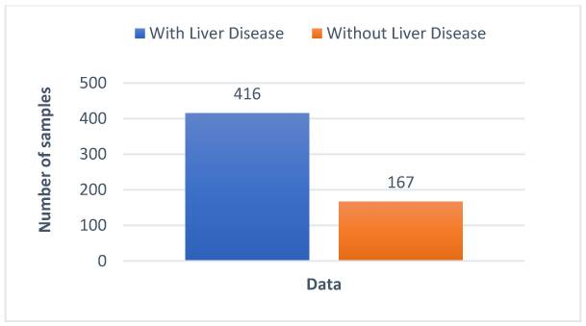
Fig 1: Dataset distribution graph by [1]
The study demonstrates that ensemble-based approaches outperform traditional individual machine learning models when applied to the ILPD dataset. By aggregating the predictions of multiple learners, the proposed method reduces overfitting and improves generalization on unseen data. The experimental results reported in the paper show improved accuracy and reliability in liver disease prediction, validating the effectiveness of the enhanced preprocessing pipeline combined with ensemble learning.
As said in [1] the dataset is then split into training and test sets in order to train and assess the machine learning models. Machine learning models are trained on the created training set in order to classify the liver disease. The trained model is then tested on the test set and its performance is assessed using various metrics. The architecture of the above method is illustrated in Fig 2.

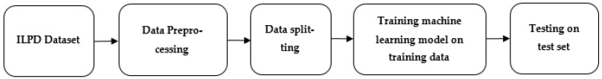
Fig 2: The proposed architecture by [1]
The core contribution of this work lies in its emphasis on preprocessing and ensemble learning. The authors highlight that raw medical datasets often contain missing values, noise, and class imbalance, which can negatively impact model performance. To address these issues, the study applies data cleaning, normalization, and preprocessing steps before model training. The processed data is then used to train ensemble classifiers, which combine multiple decision models to improve robustness and prediction accuracy compared to single classifiers.

2.Diagnosis of Liver Diseases using Machine Learning
Microarray analysis is a bioinformatics technique used to measure the expression levels of thousands of genes simultaneously from a biological sample. In the context of liver disease diagnosis, microarray data captures changes in gene expression patterns associated with diseased and healthy liver conditions. These high-dimensional gene expression profiles are then processed using computational and machine learning techniques to identify significant genes and patterns that can discriminate between different liver disease states. By combining microarray analysis with machine learning, the study aims to improve diagnostic accuracy by uncovering molecular-level markers that may not be evident through conventional clinical parameters alone.
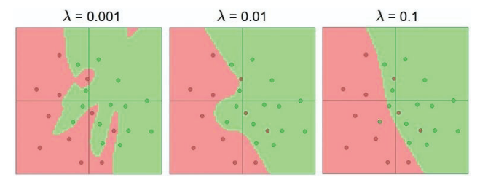
Fig 3: Effect of regularization strength by [2]
As mentioned in [2], Linking the microarray to pathogenic occurrences can be done with or without prior knowledge of the gene function. These are called supervised and unsupervised methods of learning respectively. Another method clusters known disease states and then ascertains which disease state the unknown gene expression belongs to. Support Vector Machines and artificial neural networks and others fall into this category. Binary classification as in this case is an intrinsically simpler problem to solve than multiclass classification. In binary classification, the algorithm can carveout the appropriate boundary for one class. The complement of this space contains the remaining data points. Ways to improve the strength of the classifier can be to reduce the regularization constant (lambda) or in the case of Artificial Neural Networks, increase the depth of the network. Fig 3 shows the improvement in predictive power after reduction in the regularization constant on a test data set for binary classification.

3.Liver Disease Prediction and Classification using Machine Learning Techniques
The authors of [3] emphasize that traditional diagnostic approaches rely heavily on expert interpretation of biochemical tests, which can be error-prone and inconsistent. To address this, the study explores data-driven machine learning models as a reliable decision-support tool.
Classification algorithms are often defined to be used for forecasting the liver disease as they can help predict whether a patient has the disease or not based on certain features or characteristics. Based on the existing solutions, it was found that the F-Tree algorithm shows the highest accuracy among the algorithms tested, making it a suitable choice for forecasting liver disease. Feature selection along with the fuzzy K means classification methods are commonly used in the classification of liver diseases.
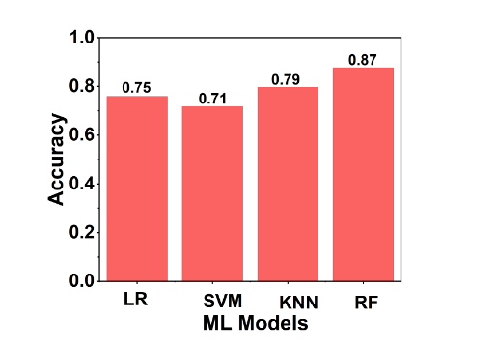
Fig 4: The accuracy of each machine learning technique used for classification is compared with others by [4]
According to Fig.4 it shows Random Forest technique is the most accurate of the ml techniques. The comparative results shown in the figure highlight the effectiveness of different machine learning approaches for liver disease prediction using clinical data. The study evaluates four widely used classifiers - Logistic Regression, Support Vector Machine, K-Nearest Neighbours, and Random Forest - to understand how model complexity and learning strategy influence diagnostic accuracy. The observed variation in performance reflects how different algorithms respond to the characteristics of medical datasets, such as feature interdependence, non-linearity, and noise.
Logistic Regression achieves moderate accuracy, indicating that linear models can capture basic trends in liver function parameters but may fail to model complex relationships among biochemical attributes. Support Vector Machine records relatively lower accuracy, which suggests that its performance is sensitive to kernel selection and hyperparameter tuning, especially when dealing with heterogeneous clinical data. K-Nearest Neighbours performs better by leveraging similarity-based learning, effectively identifying local patterns in patient data that correlate with liver disease presence.
The Random Forest model demonstrates the highest accuracy, emphasizing the strength of ensemble learning in medical prediction tasks. By aggregating multiple decision trees and introducing randomness in feature selection, Random Forest reduces overfitting and improves generalization. This makes it particularly suitable for healthcare datasets that contain overlapping feature distributions and non-linear interactions. The results reinforce the idea that ensemble models are more robust and reliable for clinical decision support systems.
Overall, the findings presented in the figure support the paper’s conclusion that machine learning-based diagnostic frameworks can significantly enhance liver disease prediction. The comparative evaluation provides empirical evidence for selecting Random Forest as a preferred model in similar healthcare applications and underscores the importance of algorithm selection in achieving accurate and dependable diagnostic outcomes.
5.Predicting liver disorder based on machine learning models
The research outlined in [5] investigates the use of machine learning models to predict liver disorder, specifically focusing on diseases related to excessive alcohol consumption. The authors point out that the liver plays a central role in detoxification, and alcohol-related liver damage is a serious global health issue. Traditional clinical diagnosis relies on biochemical tests but can miss subtle patterns in data. The study proposes a data-driven approach using machine learning to assist diagnosis by learning patterns in laboratory and demographic data that correlate with liver disorder.
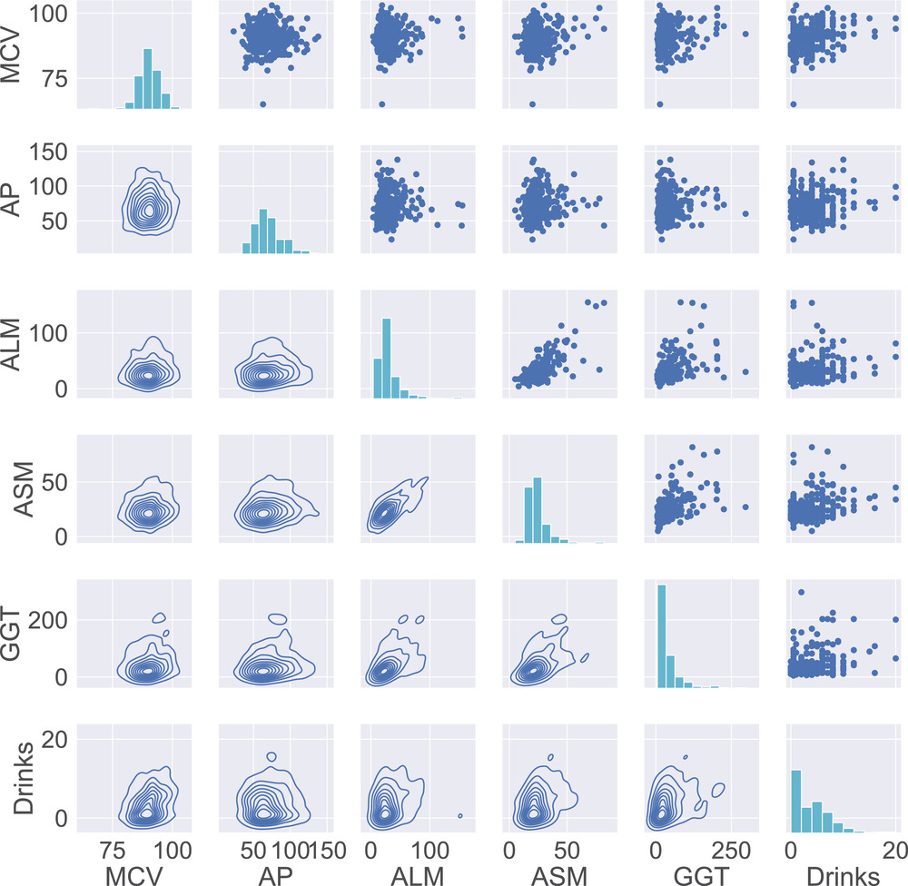
Fig 5: The relationships between different features for the liver disorder data set by [5]
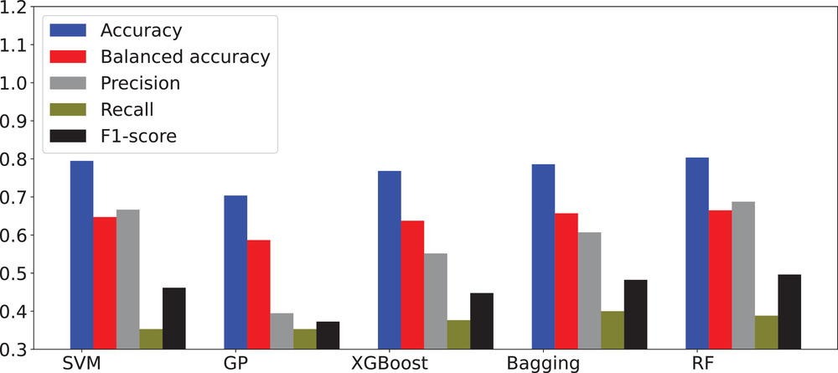
Fig 6: Experimental results of liver disorder prediction in terms of accuracy, balanced accuracy, precision, recall, and F1-score by [5]
Figure 5 presents a pairwise relationship analysis of the key clinical features used for liver disorder prediction, namely MCV (Mean Corpuscular Volume), AP (Alkaline Phosphatase), ALM (Alanine Aminotransferase), ASM (Aspartate Aminotransferase), GGT (Gamma-Glutamyl Transferase), and alcohol consumption (Drinks). The figure combines histograms (diagonal), scatter plots (upper triangle), and density contour plots (lower triangle) to provide a comprehensive exploratory data analysis of the dataset.
The diagonal histograms show the distribution of each feature individually. Most biochemical markers exhibit right-skewed distributions, particularly GGT, ALM, and ASM, indicating the presence of extreme values often associated with liver dysfunction. The “Drinks” feature also shows skewness, reflecting varying alcohol consumption levels among patients.
The scatter plots in the upper triangle illustrate pairwise interactions between features. Observable trends suggest positive correlations between liver enzyme levels, especially between ALM, ASM, and GGT, which is clinically meaningful since these enzymes tend to rise together in liver disorder cases. This visual evidence supports the idea that liver disease manifests through combined biochemical changes rather than isolated indicators.
The density contour plots in the lower triangle further emphasize regions of high data concentration. These contours reveal overlapping but distinguishable clusters, suggesting that while individual features may not perfectly separate healthy and disordered cases, their joint distributions carry discriminative information. This justifies the use of machine learning models capable of capturing non-linear and multivariate relationships.
Overall, Fig. 5 serves as an exploratory validation step, demonstrating that meaningful dependencies exist among clinical attributes. The figure supports the authors’ motivation for applying advanced machine learning and ensemble models, as simpler linear analysis would be insufficient to fully exploit these complex feature interactions. This analysis also highlights potential multicollinearity, reinforcing the suitability of tree-based and ensemble classifiers used later in the paper.
the paper demonstrates the effectiveness of machine learning techniques for predicting liver disorder using routinely available clinical and biochemical data. Through detailed exploratory analysis and comparative evaluation of multiple classifiers, the authors show that meaningful relationships exist among liver-related features and that these relationships can be successfully exploited by machine learning models. The study highlights the superiority of ensemble-based approaches in handling feature interdependencies and data imbalance, reinforcing the potential of machine learning as a reliable clinical decision-support tool for early and accurate liver disorder detection.

OBJECTIVE
Primary Aim:-
The primary aim of this project is to develop a machine learning based on liver disease screening system using the Indian Liver Patient Dataset (ILPD) that predicts the presence or absence of liver disease from routinely available biochemical and demographic data and using both supervised and unsupervised learning. In addition to classification, the project focuses on interpretability by identifying and highlighting key biochemical indicators, such as bilirubin levels, liver enzymes, and the AST/ALT (De Ritis) ratio, that contribute to the model’s predictions and indicating their direction of abnormality. By integrating predictive performance with clinically interpretable insights, the system is intended to function as a decision-support tool for early liver disease screening.
Core Features :-
- Domain-Specific Feature Engineering: Rather than relying solely on raw clinical values, the system introduces calculated medical ratios that provide deeper insight into liver pathology. By incorporating the De Ritis (AST/ALT) ratio, the bilirubin fraction (Direct vs. Total), and recalibrated Albumin-Globulin levels, the model can better differentiate between acute and chronic conditions. This transformation turns static numbers into dynamic indicators of cellular damage and organ function, aligning the machine learning logic with established hepatology practices.

- Data-Centric Preprocessing & Imbalance Correction: Medical datasets are rarely perfect, and this system uses a rigorous cleaning module to handle real-world inconsistencies. Missing values are filled using derived medians to maintain data integrity, while log and robust scaling are applied to normalize skewed biochemical markers. Crucially, the system utilizes SMOTE-ENN (Synthetic Minority Over-sampling Technique combined with Edited Nearest Neighbors) to balance the dataset. This ensures the model learns to identify liver patients effectively without being biased by a larger number of healthy records.

- Explainable AI (XAI) for Clinical Trust: To bridge the gap between "black-box" algorithms and medical expertise, the framework integrates a SHAP (SHapley Additive exPlanations) layer. This feature provides both global and local interpretations, showing exactly which biomarkers—such as a spike in alkaline phosphatase or a drop in albumin—pushed a patient’s risk score higher. By visualizing the specific contribution of each feature to a prediction, the system empowers healthcare providers to verify the model’s reasoning against their own clinical observations.

SYSTEM DESIGN
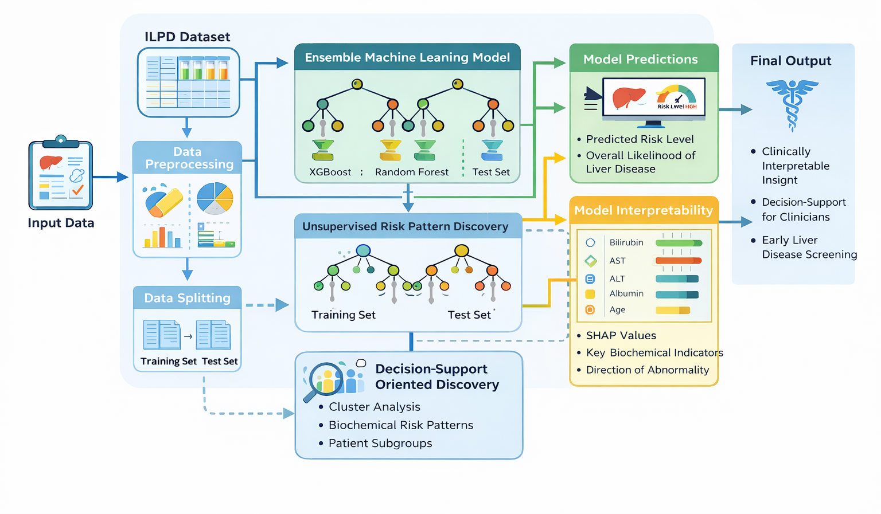
Fig 6: System design of Liver Disease Screening Using Supervised Machine Learning with Clinically Interpretable Biochemical Indicators
The system begins with the ILPD dataset as the input layer, which consists of patient-level biochemical parameters such as total and direct bilirubin, liver enzymes (AST, ALT, ALP), protein measures, albumin–globulin ratio, along with demographic attributes including age and gender. Each record represents an individual patient and serves as the foundational input for subsequent processing stages.

In the data preprocessing module, raw input data undergoes cleaning and transformation to ensure suitability for machine learning. This stage includes handling missing values, normalizing feature scales where required, and addressing class imbalance using the hybrid SMOTE-ENN technique. Additionally, clinically motivated feature engineering is performed by deriving the AST/ALT (De Ritis) ratio to capture relative enzyme elevation patterns that are indicative of liver injury. These steps enhance data quality and improve the learning capability of downstream models.
Following preprocessing, the dataset is split into training and testing subsets. The training set is used exclusively to learn model parameters, while the test set remains unseen during training to provide an unbiased evaluation of predictive performance. This separation ensures proper validation and prevents information leakage.

The architecture then branches into two parallel analytical paths. The first path represents the supervised learning component, where tree-based ensemble models—Random Forest and XGBoost—are trained on the processed training data. These models learn complex, non-linear relationships between biochemical indicators and liver disease presence. The supervised models output a probability-based prediction indicating whether liver disease is likely present or absent for a given patient.

The second path corresponds to the unsupervised learning component, which operates independently of disease labels. Clustering techniques are applied to the biochemical features to identify latent patient subgroups and biochemical risk patterns based on similarity. This module enables the discovery of distinct laboratory profiles that may correspond to varying risk levels or abnormality patterns, thereby supporting patient stratification and deeper clinical insight.
To ensure transparency and clinical usability, the system incorporates a model interpretability layer. This layer employs SHAP-based explanations to identify key biochemical indicators that influence individual predictions. It highlights the contribution of features such as bilirubin levels, liver enzymes, albumin, age, and the De Ritis ratio, along with the direction of abnormality (elevated or reduced). This interpretability mechanism bridges the gap between machine learning outputs and clinical reasoning.
Finally, the output module presents an integrated result that combines supervised prediction, interpretability insights, and unsupervised risk patterns. The output includes the predicted likelihood of liver disease, influential biochemical markers, and identified risk profiles. The system is explicitly designed as a screening and decision-support tool, assisting clinicians in early identification and risk assessment without replacing medical diagnosis.
Overall, the system architecture emphasizes robustness, interpretability, and clinical relevance by combining predictive modeling with explainable and exploratory analyses, making it suitable for real-world liver disease screening applications using routinely available laboratory data.

METHODOLOGY
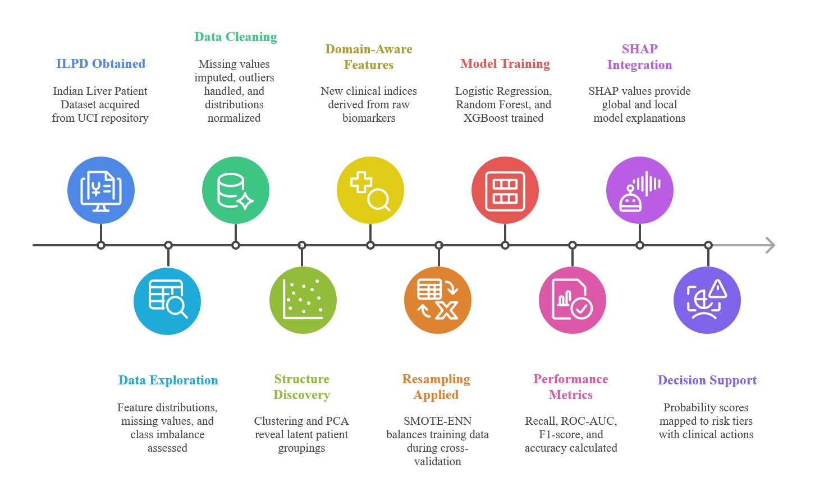
Fig 7: Methodology
The methodology of the proposed system follows an end-to-end machine learning pipeline designed to transform raw clinical data into an interpretable liver disease risk prediction. The overall workflow, as illustrated in the diagram, consists of sequential and logically connected stages that ensure data quality, robust learning, and clinically meaningful outputs.
A. Dataset Acquisition (ILPD Obtained)
The process begins with the acquisition of the Indian Liver Patient Dataset (ILPD) from the UCI Machine Learning Repository. The dataset contains patient-level demographic information and routine liver function biomarkers. Each record represents an individual patient, and the target variable indicates the presence or absence of liver disease. This labeled dataset forms the foundation for supervised learning.
B. Data Exploration
Prior to model development, exploratory data analysis is performed to understand the underlying structure of the dataset. Feature distributions are examined to identify skewness and non-normality in biochemical parameters. Missing values and class imbalance are assessed, and correlations between features are inspected. This step provides critical insights that guide preprocessing, feature engineering, and model selection.
C. Data Cleaning
Following exploration, data cleaning is carried out to improve data reliability. Missing values are imputed using robust strategies such as median imputation to reduce sensitivity to extreme pathological values. Outliers are handled using clinically valid thresholds to ensure that biologically meaningful extreme values are retained. Feature distributions are normalized to ensure consistency across variables and improve model stability.
D. Structure Discovery (Unsupervised Learning)
Unsupervised learning techniques are applied to discover latent structures within the dataset. Clustering methods and Principal Component Analysis (PCA) are used to identify natural groupings of patients based on biochemical similarity and to visualize feature interactions. This step does not contribute directly to prediction but supports understanding of patient subgroups, feature relationships, and borderline cases.
E. Domain-Aware Feature Engineering
To incorporate clinical reasoning into the learning process, domain-aware features are derived from raw biomarkers. Key engineered features include clinically established indices such as the AST/ALT (De Ritis) ratio and other relevant biochemical ratios. These features encode pathophysiological relationships that are not explicitly captured by raw laboratory values, enhancing both predictive performance and interpretability.
F. Resampling Applied (Class Imbalance Handling)
Given the imbalanced nature of the dataset, a hybrid resampling technique, SMOTE-ENN, is applied during model training. This approach generates synthetic samples for the minority class while removing noisy or ambiguous data points near class boundaries. Resampling is applied only to training data during cross-validation to prevent data leakage and ensure unbiased evaluation.
G. Model Training (Supervised Learning)
Multiple supervised machine learning models are trained using the processed dataset. Logistic Regression is used as an interpretable baseline model, while Random Forest and XGBoost are employed to capture non-linear relationships and complex feature interactions. These models learn patterns associated with liver disease presence from labeled data and output probability-based predictions.
H. Performance Metrics
Model performance is evaluated using clinically relevant metrics. Recall (sensitivity) is prioritized to minimize missed disease cases, while ROC–AUC and F1-score provide complementary evaluation of discriminative ability and class balance. Accuracy is reported but not used as the primary performance indicator due to class imbalance considerations.
I. SHAP Integration (Model Explainability)
To ensure transparency and clinical trust, SHapley Additive exPlanations (SHAP) are integrated into the pipeline. SHAP provides both global explanations, identifying dominant predictors across the dataset, and local explanations, explaining individual predictions. This enables clinicians to understand which biochemical indicators influenced a given risk prediction and in which direction.
J. Decision Support and Risk Stratification
In the final stage, predicted probabilities are mapped to discrete risk tiers such as low, intermediate, and high risk. Each tier is associated with suggested clinical actions, transforming raw model outputs into actionable decision-support information. The system is explicitly designed as a screening and support tool, assisting clinicians in early identification and risk assessment rather than replacing diagnostic judgment.

